DIGITAL COMMUNICATION SYSTEMS

DIGITAL ASSIGNMENT

PART – A

SECTION-2

NAME: V Sandeep Reddy

REGNO: 18BEC1034

1. How to Digitize the Data?

* Sampling theorem transforms the continuous signal data into discrete signal by Nyquist criterion. “A signal can be produced exactly in discrete signal if it is sampled at the rate of ‘fs’ which is greater than twice of the maximum frequency of original signal. The Quantization process is induced to quantize the signal in order to make amplitude and time domain of the signal discrete. The resulting signal is discretized signal. The Line coding schemes are involved to transform the discrete data into binary digital data.
* Digitization – Sampling🡪Quantization🡪Coding.

1. How to Record the phenomenon?

* At sea level, the air that surrounds us presses down on our bodies at 14.7 pounds per square inch. You don't feel it because the fluids in your body are pushing outward with the same force.
* Dive down into the ocean even a few feet, though, and a noticeable change occurs. You can feel an increase of pressure on your eardrums. This is due to an increase in hydrostatic pressure, the force per unit area exerted by a liquid on an object. The deeper you go under the sea, the greater the pressure of the water pushing down on you. For every 33 feet (10.06 meters) you go down, the pressure increases by one atmosphere.
* Submersible level transmitters consist of a sensor attached to a long cable, which is then lowered to the bottom of the liquid vessel. The sensor operates by measuring the hydrostatic pressure of the liquid medium. Also known as the head pressure, hydrostatic pressure is the pressure exerted by the fluid in the vessel. The level of hydrostatic pressure as measured by the sensor is determined by two things: the density of the liquid and its height. With liquid density remaining constant, changes in hydrostatic pressure necessarily reflect a difference in the liquid level.

1. What kind of transducer is used to record the non-linear phenomenon?

* Submersible pressure transducers, when combined with electronic data recorders have made it possible to collect continuous or nearly continuous water-level or pressure data from wells, piezometers, soil-moisture tensiometers, and surface water gages.
* Of course, nothing occurs in a vacuum – especially not pressure sensing. Atmospheric conditions affecting barometric pressure above the liquid line affect the hydrostatic pressure at the bottom of the vessel as well as liquid levels. Invented or non-pressurized vessel applications where atmospheric pressure is subject to change, submersible level sensors are therefore equipped with venting to compensate, maintaining the integrity of the hydrostatic pressure readings.
* And we cannot measure the volume directly, the pressure reading has to be converted into a volume using a conversion factor or formula.
* Suppose we take in the case of a tank for a tank that has a straight vertical shape (e.g. an upright cylinder), the volume calculation is very simple. A pressure sensor mounted in the bottom of the tank is used to measure the hydrostatic pressure of the water pushing down on the bottom.
* The hydrostatic pressure is directly proportional to the water level.

e.g. 100mbar ~ 1 metre of water

* Since the cross sectional area of the cylindrical tank is constant all the way up, you only have to multiply the water level by the area in square metres to calculate the total volume of water in a vertical cylindrical tank.

e.g. 1 metre diameter tank with a hydrostatic pressure of 50mbar would contain approx. 0.39 cubic metres or 390 Litres

1. Why only Submersible pressure transducer?

* The compact, sophisticated nature of the sensor unit, along with the possibility of cable lengths up to 2,500 feet in special situations, makes submersible level sensors particularly versatile.

1. What kind of Quantization is used?

* Since the slope of the graph is not changing rapidly we can perform the uniform quantization.

Section -3

Code:

clc

close all

v = [12 13 14 15 16 17 18 19 20 21 22 23 24 26 28 30 32 34 36 38 40 42 44 46 48];

p = [117.56 107.81 100.44 93.06 87.88 82.75 77.88 74.13 70.69 67.06 64.06 61.31 58.81 54.31 50.31 47.06 44.19 41.63 39.31 37.00 35.31 33.50 31.94 30.56 29.13];

plot(v,p)

figure(1)

title('Voulme vs Pressure','FontSize',12,'FontWeight',"bold");

xlabel('Volume','FontSize',12,'FontWeight',"bold");

ylabel('Pressure','FontSize',12,'FontWeight',"bold");

figure(2)

stem(v,p); % plot of sampled signal

title('SAMPLED SIGNAL','FontSize',12,'FontWeight',"bold");

xlabel('Volume','FontSize',12,'FontWeight',"bold");

ylabel('Pressure','FontSize',12,'FontWeight',"bold");

n1=5;%number of bits per sample

L=2^n1;%number of quantization levels

xmax=1.3e+08;%max value of quantization vector

xmin=0;%min value of quantization vector

del=(xmax-xmin)/L; %Difference between each quantization level

partition=xmin:del:xmax% definition of decision lines

codebook=xmin-(del/2):del:xmax+del/2; % definition of representation levels

[index,quants]=quantiz(p,partition,codebook);%quantiz is inbuilt function which is used to quantize the signal

% gives rounded off values of the samples

figure(3)

set(gca,'Fontsize',8,'Fontweight','bold')

stem(quants,"color",'r');%plotting of quantized signal

title('QUANTIZED SIGNAL');

xlabel('Volume','FontSize',8,'FontWeight',"bold");

ylabel('Pressure','FontSize',8,'FontWeight',"bold");

% NORMALIZATION

l1=length(index); % to convert 1 to n as 0 to n-1 indicies

for i=1:l1

if (index(i)~=0)

index(i)=index(i)-1;

end

end

l2=length(quants);

for i=1:l2 % to convert the end representation levels within the range.

if(quants(i)==xmin-(del/2))

quants(i)=xmin+(del/2);

end

if(quants(i)==xmax+(del/2))

quants(i)=xmax-(del/2);

end

end

% ENCODING

code=de2bi(quants,'left-msb'); % Decimal to binary conversion of quantization vector

k=1;

for i=1:l1 % to convert column vector to row vector

for j=1:n1

coded(k)=code(i,j);

j=j+1;

k=k+1;

end

i=i+1;

end

figure(4);

stairs(coded);%plotting digital signal

xlim([0,400])

ylim([-1 2])

%plot of digital signal

title('DIGITAL SIGNAL');

set(gca,'Fontsize',8,'Fontweight','bold')

xlabel('volume','FontSize',8,'FontWeight',"bold");

ylabel('pressure','FontSize',8,'FontWeight',"bold");

%Demodulation

code1=reshape(coded,n1,(length(coded)/n1));

index1=bi2de(code1,'left-msb');

resignal=del*index+xmin+(del/2);%decoding the binary sequence

figure(5);%plot of demodulated signal compared to original signl

subplot(2,1,1)%plot of demodulated signal

plot(v,resignal,"color",'k');

set(gca,'Fontsize',8,'Fontweight','bold')

title('DEMODULATAED SIGNAL');

xlabel('volume','FontSize',8,'FontWeight',"bold");

ylabel('pressure','FontSize',8,'FontWeight',"bold");

subplot(2,1,2)

plot(v,p,"color",'m');%plot of original signal

set(gca,'Fontsize',8,'Fontweight','bold')

title('ORIGINALSIGNAL');

xlabel('volume','FontSize',8,'FontWeight',"bold");

ylabel('pressure','FontSize',8,'FontWeight',"bold");

OUTPUT:

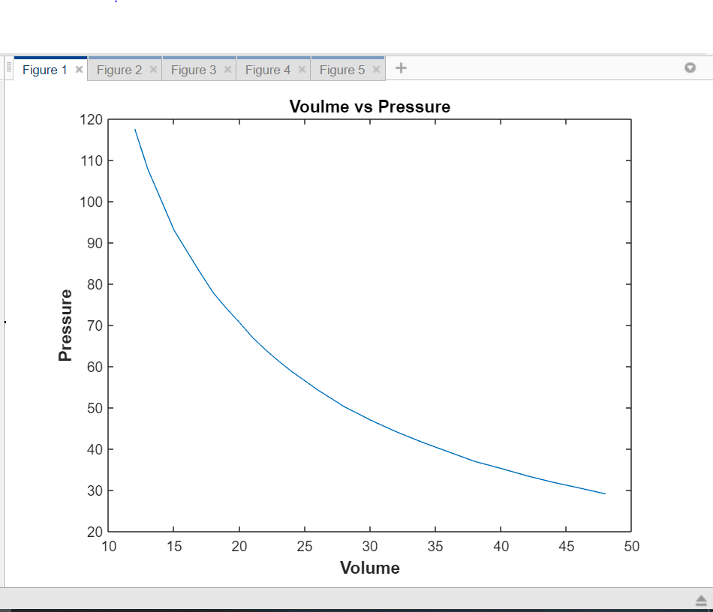

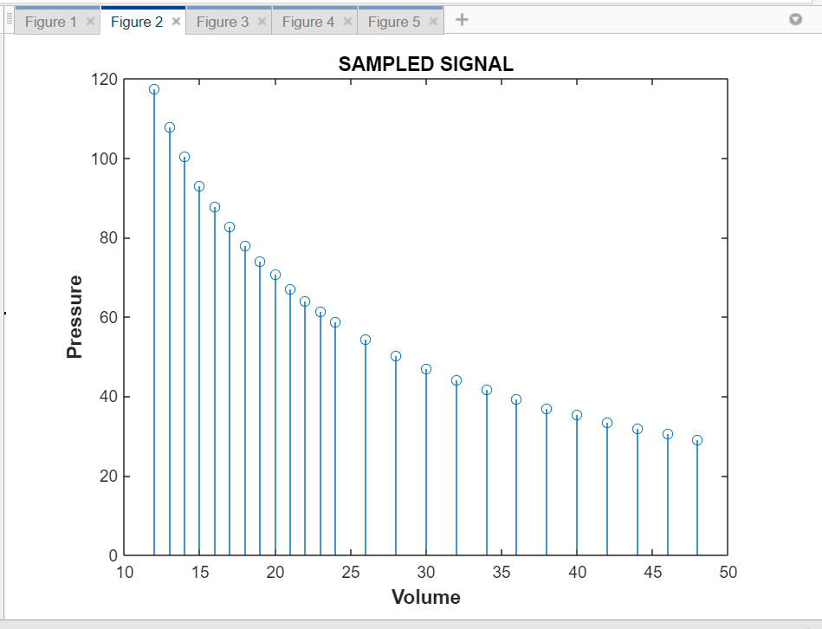

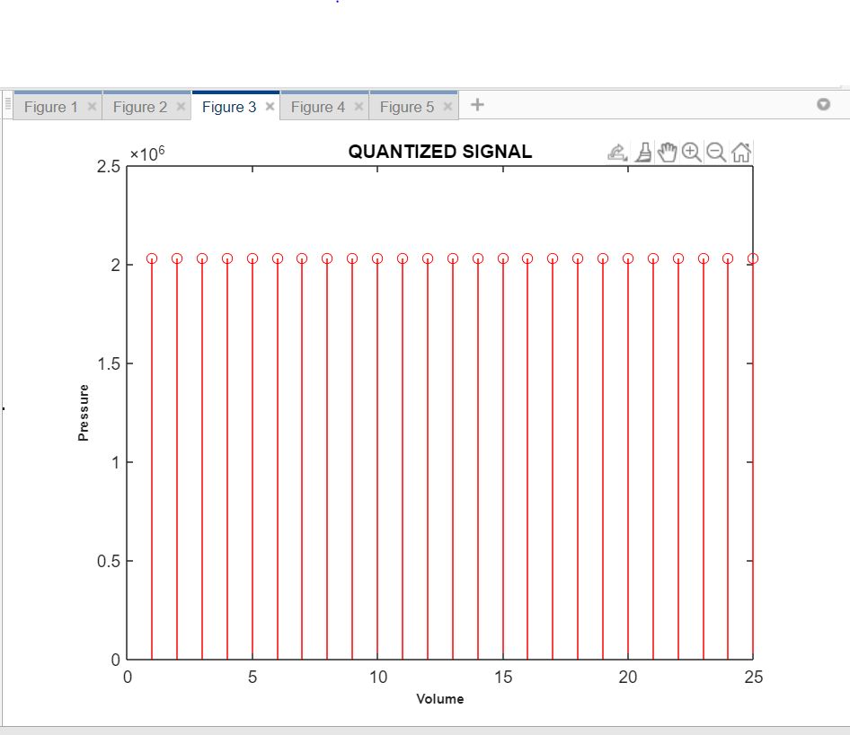

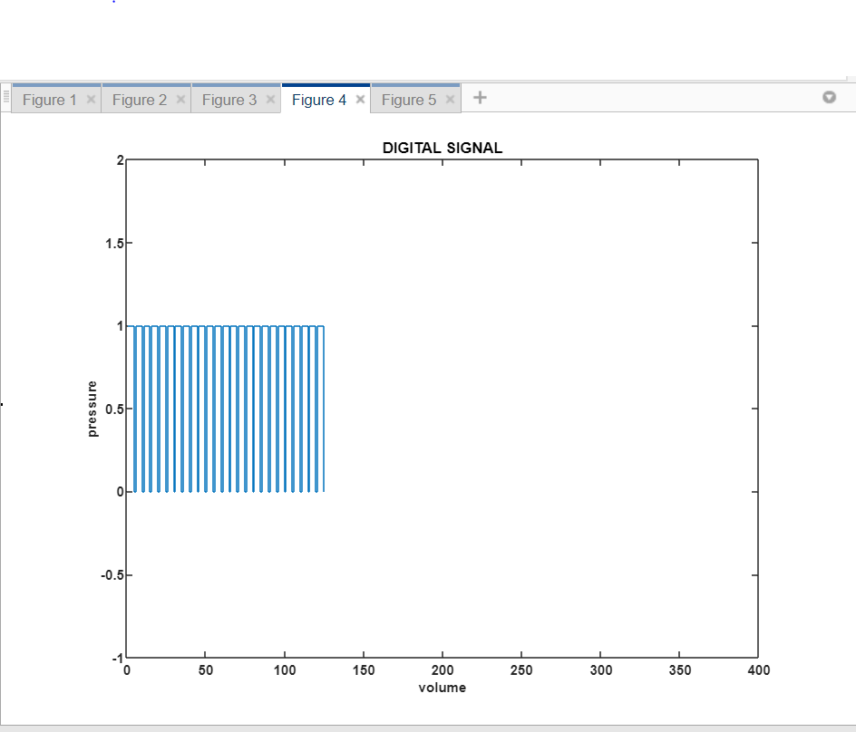

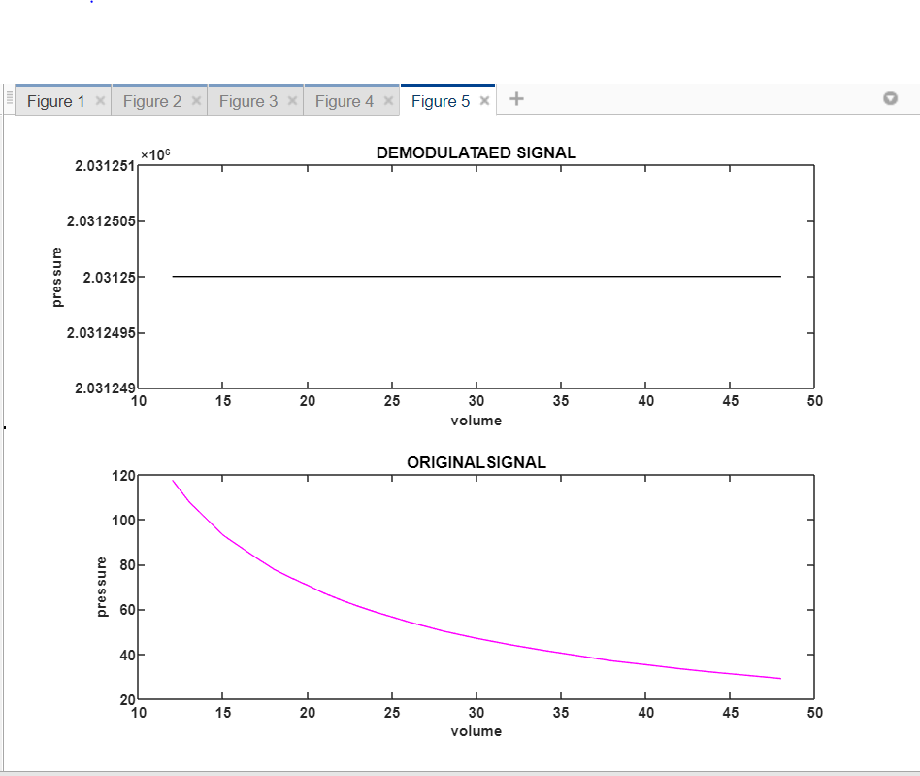

References:

https://www.scubadiver-ed.com/openwater20/studyGuide/Effects-of-Pressure-Volume-and-Density-on-Scuba-Diving/1201002_62991/#:~:text=As%20the%20pressure%20increases%20with,and%20the%20density%20will%20increase.&text=This%20is%20because%20as%20the,denser%20gas%20means%20more%20gas.